Exercise 19: PropTypes

Objectives and Outcomes

PropTypes is a library in React that allows you to specify the expected types of props passed to a component. It helps in validating and documenting the expected props, ensuring that they are of the correct type.

Exercise

* [Step 1 — Creating an Empty Project](https://www.digitalocean.com/community/tutorials/how-to-customize-react-components-with-props#step-1-creating-an-empty-project) named prop_example
* [Step 2 — Building Dynamic Components with Props](https://www.digitalocean.com/community/tutorials/how-to-customize-react-components-with-props#step-2-building-dynamic-components-with-props)

Create a component that will display information about animals. This component will take the name and scientific name of the animal as strings, the size as an integer, the diet as an array of strings, and additional information as an object. You’ll pass the information to the new component as props and consume that information in your component.

By the end of this step, you’ll have a custom component that will consume different props. You’ll also reuse the component to display an array of data using a common component.

[**Adding Data**](https://www.digitalocean.com/community/tutorials/how-to-customize-react-components-with-props#adding-data)

export default [

{

name: 'Lion',

scientificName: 'Panthero leo',

size: 140,

diet: ['meat'],

},

{

name: 'Gorilla',

scientificName: 'Gorilla beringei',

size: 205,

diet: ['plants', 'insects'],

additional: {

notes: 'This is the eastern gorilla. There is also a western gorilla that is a different species.'

}

},

{

name: 'Zebra',

scientificName: 'Equus quagga',

size: 322,

diet: ['plants'],

additional: {

notes: 'There are three different species of zebra.',

link: 'https://en.wikipedia.org/wiki/Zebra'

}

}

]

[**Creating Components**](https://www.digitalocean.com/community/tutorials/how-to-customize-react-components-with-props#creating-components) called AnimalCard. This component will eventually take props and display the data.

**Create a function** called showAdditionalData that will convert the object to a string and display it as an alert. The function showAdditional converts the object to an array of pairs where the first item is the key and the second is the value. It then maps over the data converting the key-pair to a string. Then it joins them with a line break—\n—before passing the complete string to the alert function.

Then create a <button> with an [onClick event](https://www.digitalocean.com/community/tutorials/how-to-create-react-elements-with-jsx" \l "step-3-%E2%80%94-adding-events-to-elements) that calls the function with the additional object:

When you do, the browser will refresh and you’ll see a button after each card. When you click the button, you’ll get an alert with the additional data.

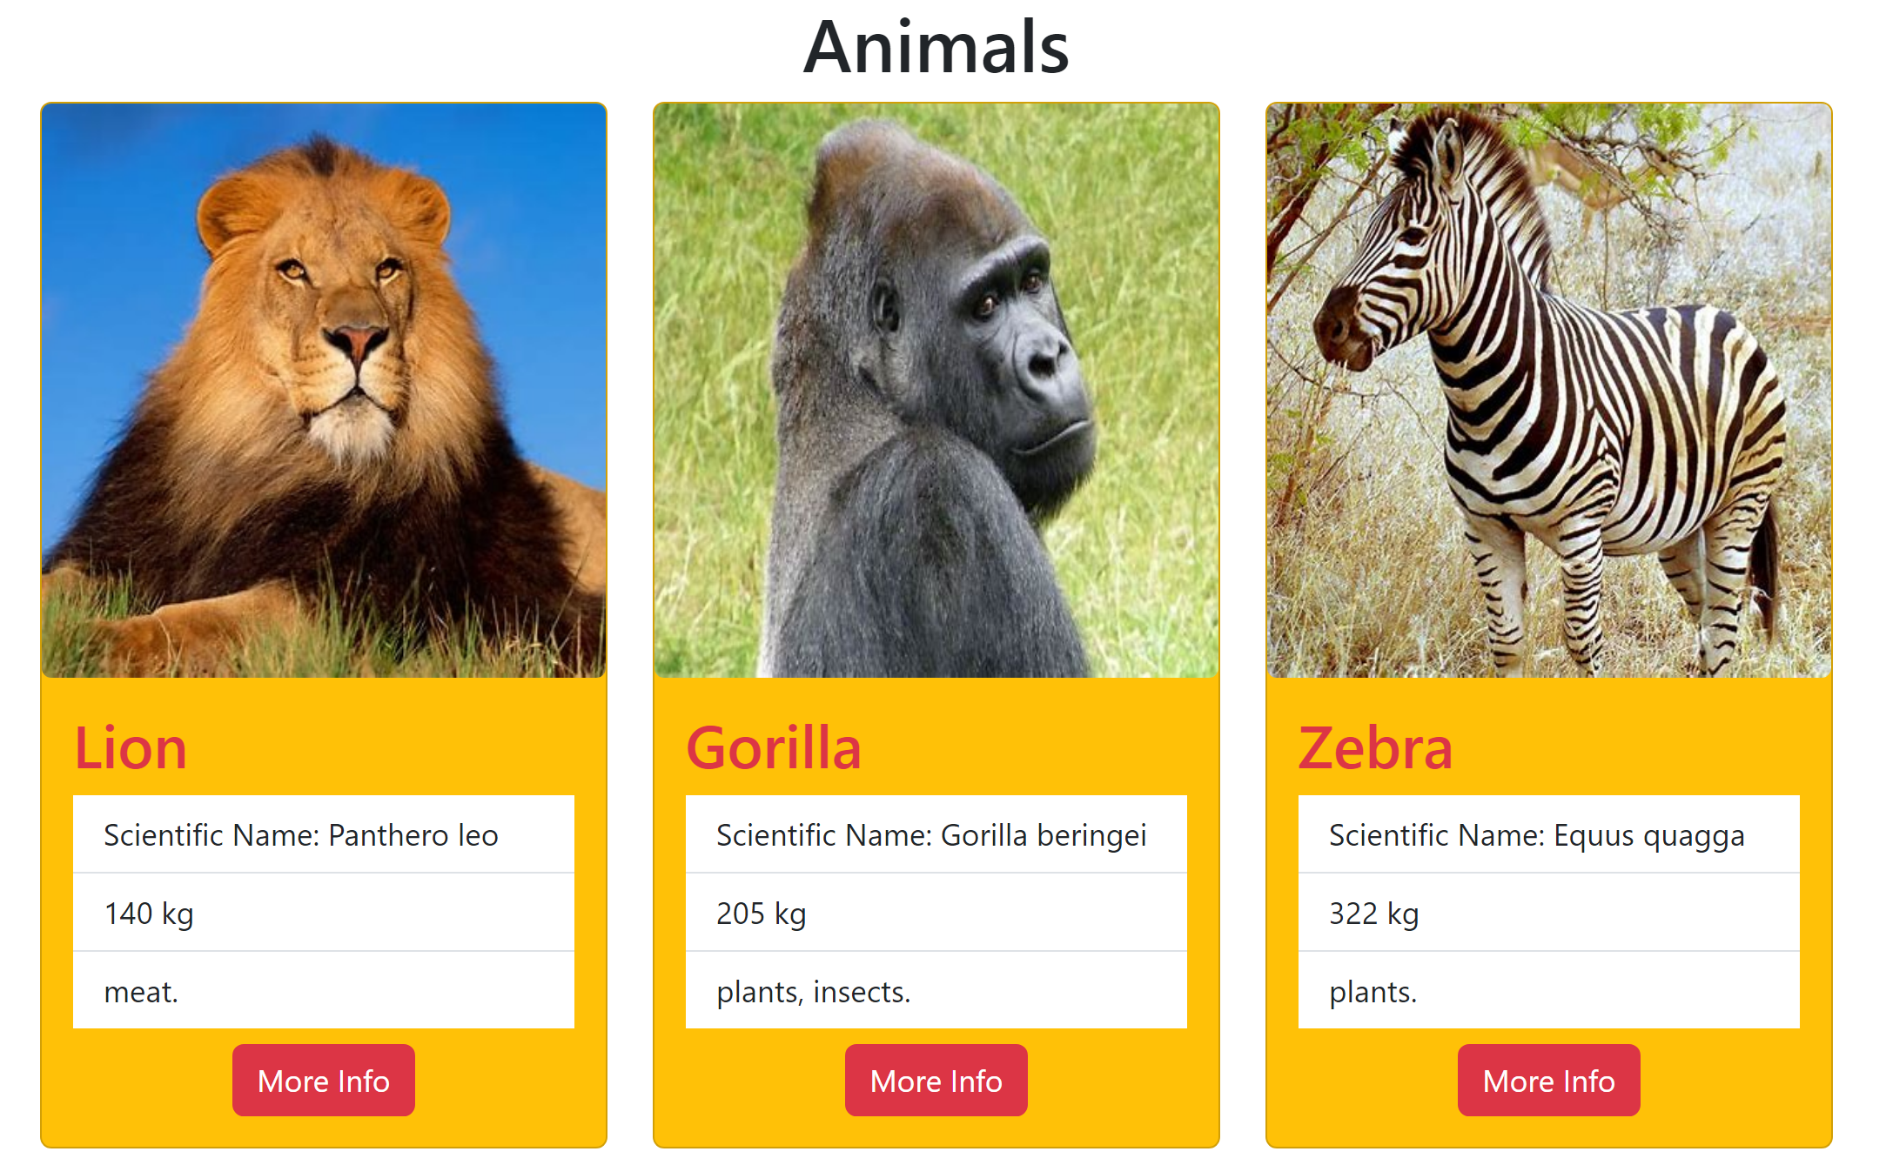

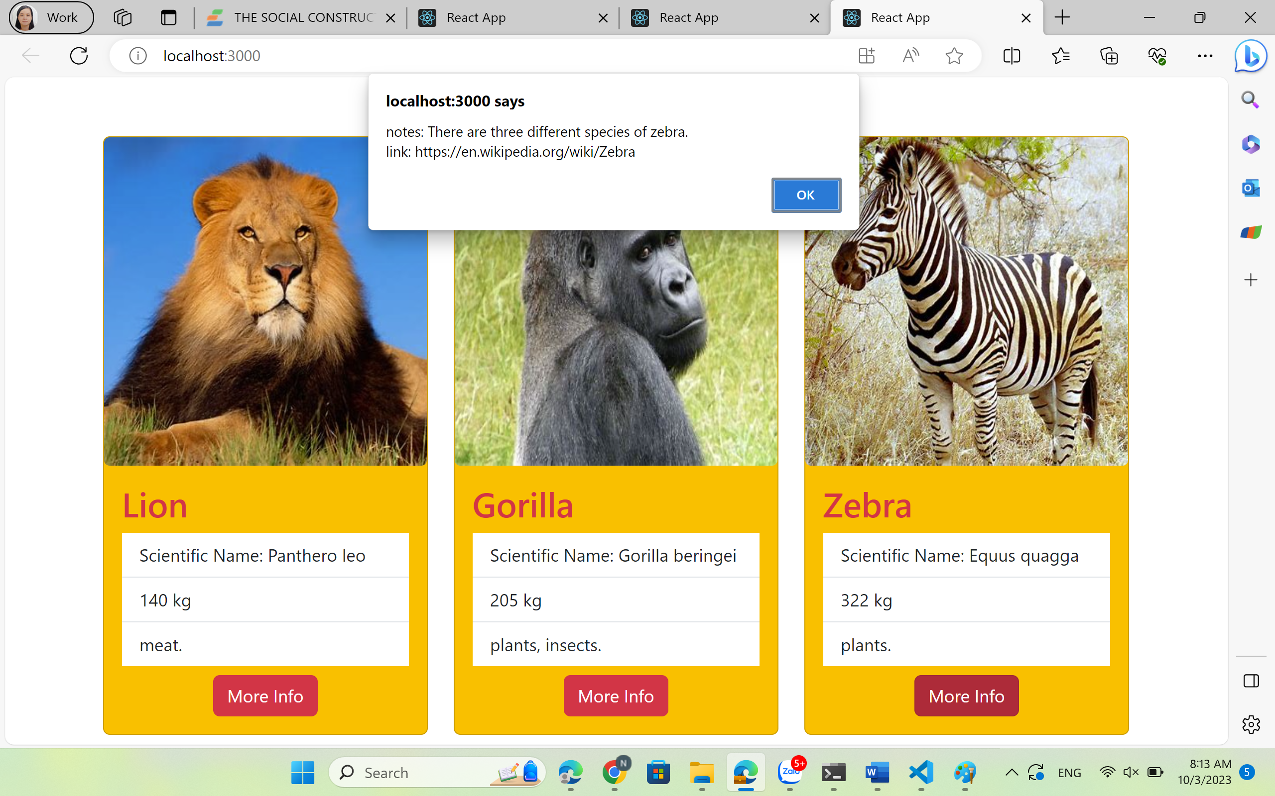

If you try clicking **More Info** for the Lion, you will get an error. That’s because there is no additional data for the lion. You’ll see how to fix that in Step 3.

1. [Step 3 — Creating Predictable Props with PropTypes and defaultProps](https://www.digitalocean.com/community/tutorials/how-to-customize-react-components-with-props#step-3-creating-predictable-props-with-proptypes-and-defaultprops)

In this step, you’ll add a light type system to your components with PropTypes. PropTypes act like other type systems by explicitly defining the type of data you expect to receive for a certain prop. They also give you the chance to define default data in cases where the prop is not always required. Unlike most type systems, PropTypes is a runtime check, so if the props do not match the type the code will still compile, but will also display a console error.

By the end of this step, you’ll add predictability to your custom component by defining the type for each prop. This will ensure that the next person to work on the component will have a clear idea of the structure of the data the component will need.

Add PropTypes directly to the component function

import React from 'react';

import PropTypes from 'prop-types';

import './AnimalCard.css'

export default function AnimalCard({

...

}

AnimalCard.propTypes = {

additional: PropTypes.shape({

link: PropTypes.string,

notes: PropTypes.string

}),

diet: PropTypes.arrayOf(PropTypes.string).isRequired,

name: PropTypes.string.isRequired,

scientificName: PropTypes.string.isRequired,

showAdditional: PropTypes.func.isRequired,

size: PropTypes.number.isRequired,

}

Here, you are specifying that name must be a string. The property scientificName is the same. size is a number, which can include both floats such as 1.5 and integers such as 6. showAdditional is a function (func). diet, on the other hand, is a little different. In this case, you are specifying that diet will be an array, but you also need to specify what this array will contain. In this case, the array will only contain strings. If you want to mix types, you can use another prop called oneOfType, which takes an array of valid PropTypes. You can use oneOfType anywhere, so if you wanted size to be either a number or a string you could change it to this:

size: PropTypes.oneOfType([PropTypes.number, PropTypes.string])

The prop additional is also a little more complex. In this case, you are specifying an object, but to be a little more clear, you are stating what you want the object to contain. To do that, you use PropTypes.shape, which takes an object with additional fields that will need their own PropTypes. In this case, link and notes are both PropTypes.string.

Currently, all of the data is well-formed and matches the props. To see what happens if the PropTypes don’t match, open up your data:

export default [

{

name: 'Lion',

scientificName: 'Panthero leo',

size: '140',

diet: ['meat'],

},

...

]

Save the file. When you do the browser will refresh and you’ll see an error in the console.

PropTypes will not give you a warning at build time, and as long as there are no code errors, it will still compile. This means that you could accidentally publish code with prop errors.

Change the data back to the correct type:

export default [

{

name: 'Lion',

scientificName: 'Panthero leo',

size: 140,

diet: ['meat'],

},

...

]

Every prop except for additional has the isRequired property. That means, that they are required. If you don’t include a required prop, the code will still compile, but you’ll see a runtime error in the console.

If a prop isn’t required, you can add a default value. It’s good practice to always add a default value to prevent runtime errors if a prop is not required. For example, in the AnimalCard component, you are calling a function with the additional data. If it’s not there, the function will try and modify an object that doesn’t exist and the application will crash.

To prevent this problem, add a defaultProp for additional:

import React from 'react';

import PropTypes from 'prop-types';

import './AnimalCard.css'

export default function AnimalCard({

...

}

AnimalCard.propTypes = {

additional: PropTypes.shape({

link: PropTypes.string,

notes: PropTypes.string

}),

...

}

**AnimalCard.defaultProps = {**

**additional: {**

**notes: 'No Additional Information'**

**}**

}

Add the defaultProps to the function using dot syntax just as you did with propTypes, then you add a default value that the component should use if the prop is undefined. In this case, you are matching the shape of additional, including a message that the there is no additional information.

Save and close the file. When you do, the browser will refresh. After it refreshes, click on the **More Info** button for **Lion**. It has no additional field in the data so the prop is undefined. But AnimalCard will substitute in the default prop.

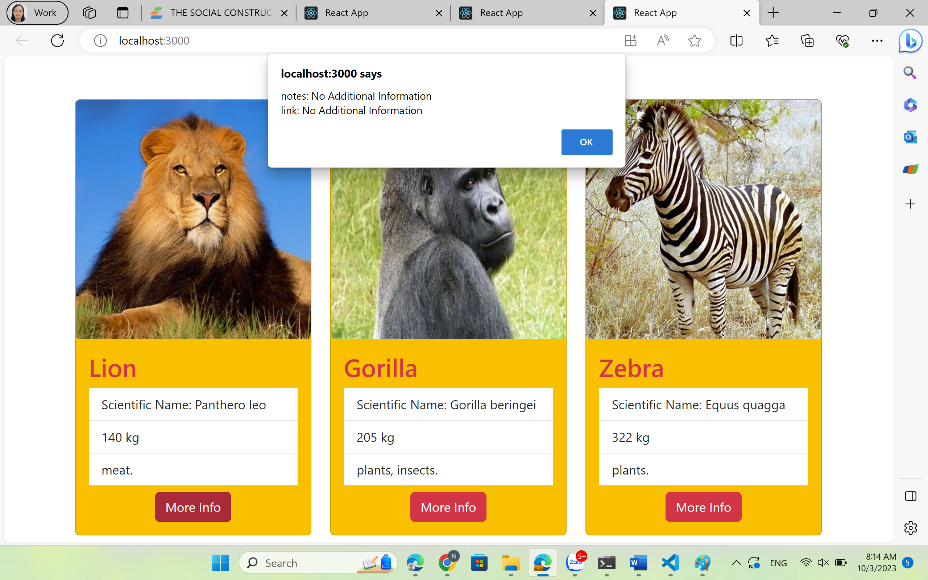

Conclusion

In conclusion, PropTypes is a library in React that allows you to specify the expected types of props passed to a component.